**INDUSTRIAL TRAINING REPORT**

**E-Commerce Website**

SUBMITTED IN PARTIAL FULFILLMENT OF THE REQUIREMENT FOR THE AWARD OF THE DEGREE OF

**BACHELOR OF TECHNOLOGY**

(Computer Science & Engineering)

**SUBMITTED BY:**

Aqir Ahmad Lone(7318107)

January 2022



**Department of Computer Science & Engineering**

**Galaxy Global Educational Trust’s Group of Institutions**

**DECLARATION**

I hereby declare that the Industrial Training Report entitled ("E-COMMERCE WEBSITE") is an authentic record of my own work as requirements of Industrial Training during the period from June to September for the award of degree of B.Tech. (Computer Science & Engineering), GALAXY GLOBAL GROUP OF INSTITUTIONS, DINARPUR.

**(Aqir Ahmad Lone)**

**( 7318107)**

**Date: ____________________**

**CERTIFICATE**

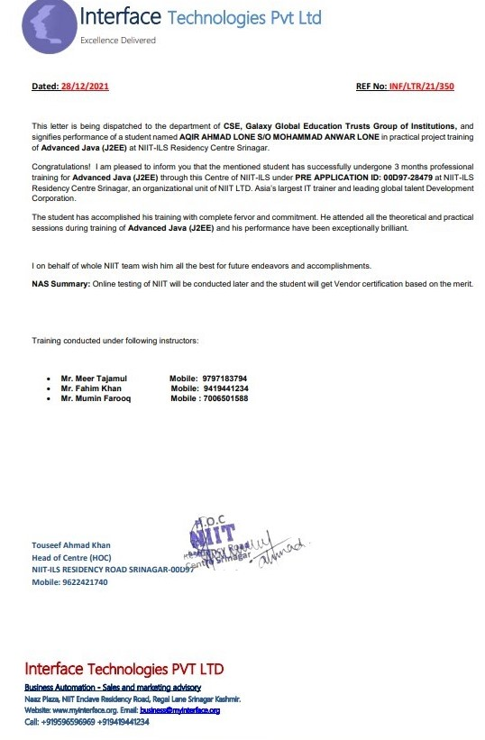

**ACKNOWLEDGEMENT**

I have taken efforts in this project. However, it would not have been possible without the kind support and help of many individuals and organizations. I would like to extend my sincere thanks to all of them.

I am highly indebted to “Mr Tawseef Ahmad” from “NIIT” for their guidance and constant supervision as well as for providing necessary information regarding the project & also for their support in completing the project.

I express my sincere thanks to **Dr. Sourabh Gupta**, Director, Galaxy Global Educational Trust’s Group of Institutions, Dinarpur , Ambala and other staff members for their support and encouragement.

I would like to express my sincere gratitude to my supervisor Er. Tarun Kumar, Head, Department of Computer Science & Engineering, Galaxy Global Educational Trust’s Group of Institutions, Dinarpur, Ambala for his constant support, inspiration and guidance in both academic and personal life. I am extremely grateful to him/her for being an excellent advisor and a wonderful teacher.

Last but not the least; I would like to express my gratitude towards my parents for their kind co-operation and encouragement which help me in completion of this project.

**Chapters**

|  |  |  |
| --- | --- | --- |
| **S. NO.** | **TOPIC** | **PAGE NO.** |
| **1.** | **Introduction to the project** | **7** |
| **2.** | **Technologies Used** | **11** |
| **3.** | **NetBeans IDE** | **12** |
| **4.** | **Java** | **13** |
| 5. | **Jsp** | **14** |
| **6.** | **Servlets** | **15** |
| **7.** | **Html** | **16** |
| **8.** | **css** | **17** |
| **9.** | **Appachi Tomcat** | **18** |
| **10.** | **GlassFish** | **19** |
| **11.** | **Code** | **20-35** |
| **12.** | **Conclusion** | **36** |

**List of figures**

|  |  |  |  |
| --- | --- | --- | --- |
| **S. NO.** | **FIGURE NO** | **DESCRIPTION** | **PAGE NO.** |
| **1.** | **Fig 1** | **Sign Up** | **8** |
| **2.** | **Fig 2** | **Home Page** | **9** |
| **3.** | **Fig 3** | **Cart page** | **9** |
| **4.** | **Fig 4** | **Address page** | **10** |
| **5.** | **Fig 5** | **Bill page** | **10** |

**Introduction to Project**

**E-Commerce Website :** The objective of this project is to develop a general-purpose e-commerce store where any product (such as books, CDs, computers, mobile phones, electronic items, and home appliances) can be bought from the comfort of home through the Internet.

An online store is a virtual store on the Internet where customers can browse the catalog and select products of interest. The selected items may be collected in a shopping cart. At checkout time, the items in the shopping cart will be presented as an order. At that time, more information will be needed to complete the transaction.

Usually the user has to login first and then he can select the products and then the user adds them in cart after then the user proceeds towards the Address page where he has to fill address and phone number .Then user prints the bill. The user can also logout from website.

**The working of the project is explained below step by step.**

* **Step 1:-**

The user Registers first by filling details like email, phone name etc:

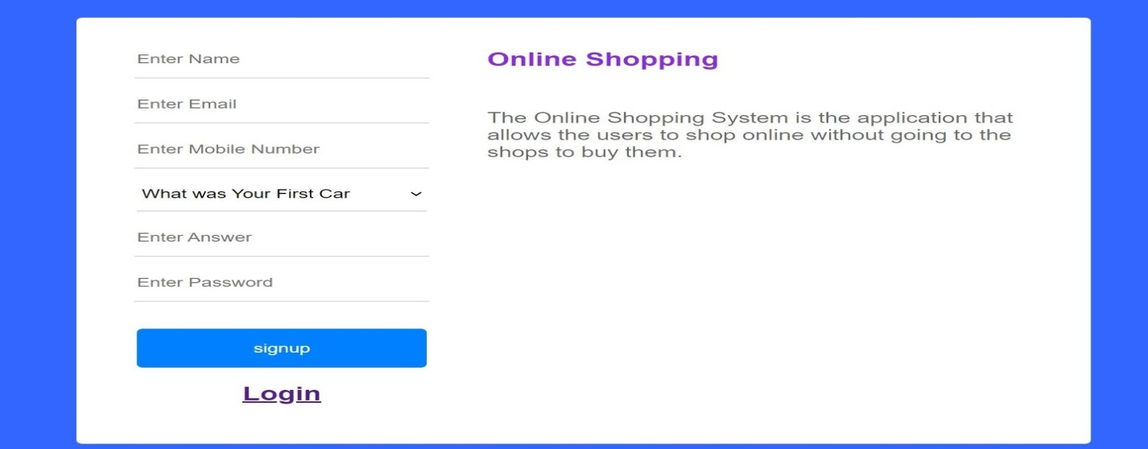

**Fig 1**

* **Step 2:** After Successfully Registering the user enters the next page where there is list of products.

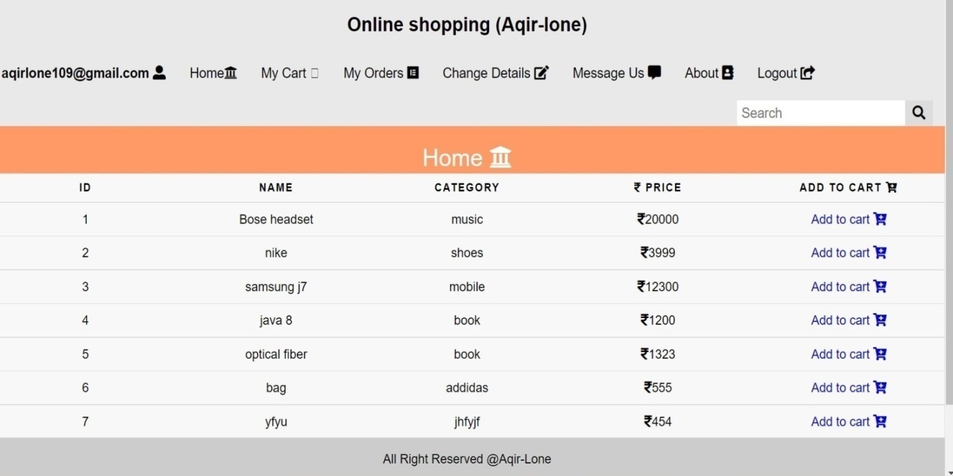

**Fig 2**

**Step 3 :**  Now user can select any product he wants to buy and can add to cart. After Adding product to cart . Here user can increase or decrease quantity or he also can remove product from cart. Then user clicks Proceed To Order for filling Address Details.

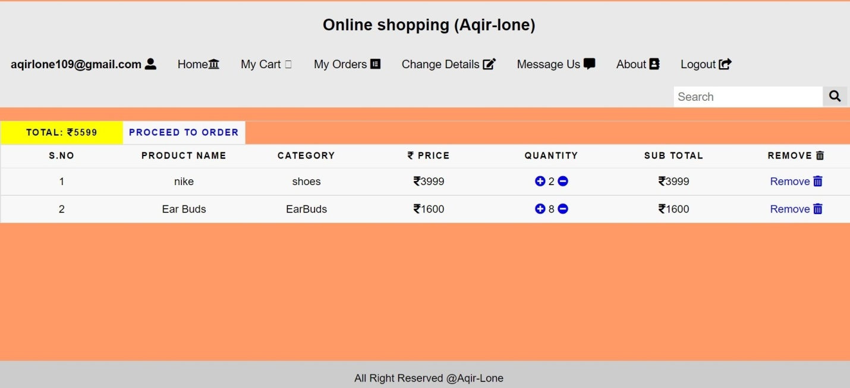

**Fig 3**

**Step 4:** Here user has to fill Address Details .

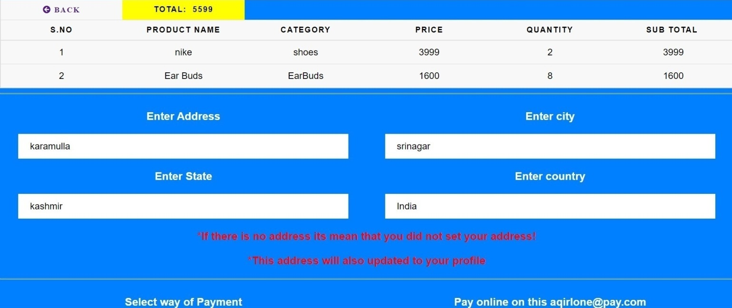

**Fig 4**

**Step 5:** User can see the bill and print it .this is the last step he can go to shop further or can print bill and order product/s.

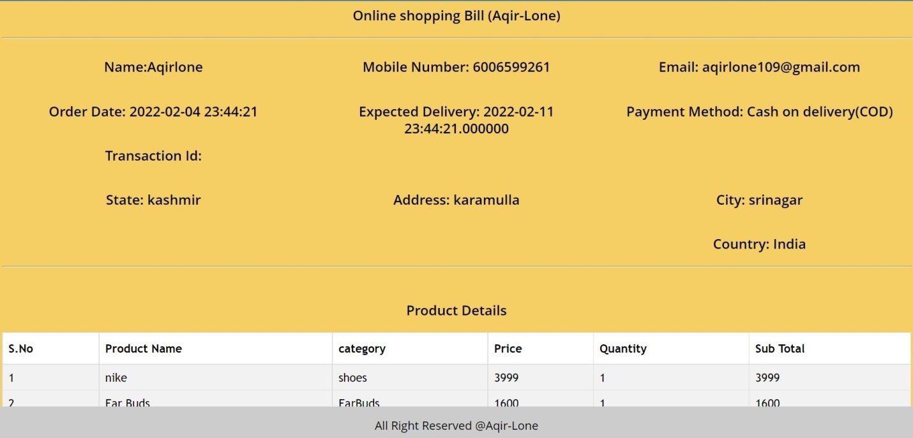

**Fig 5**

**Tools and Technologies Used**

* IDE :- Net Beans .
* Language :- Java, Jsp, Servlets, Html , Css.
* web server environment :- Appachi Tomcat.
* Library :-GlassFish.

**NetBeans IDE**

NetBeans IDE is a free, open source, integrated development environment (IDE) that enables you to develop desktop, mobile and web applications. The IDE supports application development in various languages, including Java, HTML5, PHP and C++. The IDE provides integrated support for the complete development cycle, from project creation through debugging, profiling and deployment. The IDE runs on Windows, Linux, Mac OS X, and other UNIX-based systems.

The IDE provides comprehensive support for JDK 7 technologies and the most recent Java enhancements. It is the first IDE that provides support for JDK 7, Java EE 7, and JavaFX 2. The IDE fully supports Java EE using the latest standards for Java, XML, Web services, and SQL and fully supports the GlassFish Server, the reference implementation of Java EE.

**Java**

Java is one of the most popular and widely used programming languages.

* Java has been one of the most popular programming languages for many years.
* Java is Object Oriented. However, it is not considered as pure object-oriented as it provides support for primitive data types (like int, char, etc)
* The Java codes are first compiled into byte code (machine-independent code). Then the byte code runs on **J**ava **V**irtual **M**achine (JVM) regardless of the underlying architecture.
* Java syntax is similar to C/C++. But Java does not provide low-level programming functionalities like pointers. Also, Java codes are always written in the form of classes and objects.
* Java is used in all kinds of applications like Mobile Applications (Android is Java-based), desktop applications, web applications, client-server applications, enterprise applications, and many more.
* When compared with C++, Java codes are generally more maintainable because Java does not allow many things which may lead to bad/inefficient programming if used incorrectly. For example, non-primitives are always references in Java. So we cannot pass large objects (like we can do in C++) to functions, we always pass references in Java. One more example, since there are no pointers, bad memory access is also not possible.
* When compared with Python, Java kind of fits between C++ and Python. The programs are written in Java typically run faster than corresponding Python programs and slower than C++. Like C++, Java does static type checking, but Python does not.

**Jsp**

JSP technology is used to create web application just like Servlet technology. It can be thought of as an extension to Servlet because it provides more functionality than servlet such as expression language, JSTL, etc.

A JSP page consists of HTML tags and JSP tags. The JSP pages are easier to maintain than Servlet because we can separate designing and development. It provides some additional features such as Expression Language, Custom Tags, etc.

JSP technology is the extension to Servlet technology. We can use all the features of the Servlet in JSP. In addition to, we can use implicit objects, predefined tags, expression language and Custom tags in JSP, that makes JSP development easy.

If JSP page is modified, we don't need to recompile and redeploy the project. The Servlet code needs to be updated and recompiled if we have to change the look and feel of the application.

In JSP, we can use many tags such as action tags, JSTL, custom tags, etc. that reduces the code. Moreover, we can use EL, implicit objects, etc.

**Servlets**

Servlets are the Java programs that run on the Java-enabled web server or application server. They are used to handle the request obtained from the webserver, process the request, produce the response, then send a response back to the webserver.

Properties of Servlets are as follows:

Servlets work on the server-side.

Servlets are capable of handling complex requests obtained from the webserver.

The **server-side extensions** are nothing but the technologies that are used to create dynamic Web pages. Actually, to provide the facility of dynamic Web pages, Web pages need a container or Web server. To meet this requirement, independent Web server providers offer some proprietary solutions in the form of **APIs**(Application Programming Interface).

Servlet is faster than CGI as it doesn’t involve the creation of a new process for every new request received. Servlets, as written in Java, are platform-independent.

Removes the overhead of creating a new process for each request as Servlet doesn’t run in a separate process. There is only a single instance that handles all requests concurrently. This also saves the memory and allows a Servlet to easily manage the client state.

**HTML**

HTML is a fairly simple language made up of elements, which can be applied to pieces of text to give them different meaning in a document (Is it a paragraph? Is it a bulleted list? Is it part of a table?), structure a document into logical sections (Does it have a header? Three columns of content? A navigation menu?), and embed content such as images and videos into a page. This module will introduce the first two of these and introduce fundamental concepts and syntax you need to know to understand HTML.

The head of an HTML document is the part that is not displayed in the web browser when the page is loaded. It contains information such as the page <title>, links to CSS (if you want to style your HTML content with CSS), links to custom favicons, and metadata (data about the HTML, such as who wrote it, and important keywords that describe the document).

One of HTML's main jobs is to give text meaning (also known as semantics), so that the browser knows how to display it correctly. This article looks at how to use HTML to break up a block of text into a structure of headings and paragraphs, add emphasis/importance to words, create lists, and more.

**CSS**

Cascading Style Sheets, fondly referred to as CSS, is a simple design language intended to simplify the process of making web pages presentable.

CSS handles the look and feel part of a web page. Using CSS, you can control the color of the text, the style of fonts, the spacing between paragraphs, how columns are sized and laid out, what background images or colors are used, layout designs,variations in display for different devices and screen sizes as well as a variety of other effects.

CSS is easy to learn and understand but it provides powerful control over the presentation of an HTML document. Most commonly, CSS is combined with the markup languages HTML or XHTML.

CSS saves time − You can write CSS once and then reuse same sheet in multiple HTML pages. You can define a style for each HTML element and apply it to as many Web pages as you want

Pages load faster − If you are using CSS, you do not need to write HTML tag attributes every time. Just write one CSS rule of a tag and apply it to all the occurrences of that tag. So less code means faster download times.

**Appachi Tomcat.**

It is an open-source Java servlet container that implements many Java Enterprise Specs such as the Websites API, Java-Server Pages and last but not least, the Java Servlet. The complete name of Tomcat is "Apache Tomcat" it was developed in an open, participatory environment and released in 1998 for the very first time. It began as the reference implementation for the very first Java-Server Pages and the Java Servlet API. However, it no longer works as the reference implementation for both of these technologies, but it is considered as the first choice among the users even after that. It is still one of the most widely used java-sever due to several capabilities such as good extensibility, proven core engine, and well-test and durable. Here we used the term "servlet" many times, so what is java servlet; it is a kind of software that enables the webserver to handle the dynamic(java-based) content using the Http protocols.

So what exactly is Apache tomcat?

If you are a little familiar with the websites or have some basic knowledge about the websites, you must have heard about the HTTP protocol or may also know what actually are they. If you want to provide any web-services such as you want to provide a simple static content possibly by using HTML (or Hypertext Markup Language), or maybe you just want to send data from a server to point you, so you necessarily need a server and that server is HTTP(HyperText transfer protocol). So, as we all know that if anyone wants to make a simple, static website, he definitely requires an HTTP server, but if he wants to make website dynamic, he has to use servlet. We use the HTTP server if we want to send simple data. If we want to send dynamic data or to make our website dynamic, we need to use the servlet. Hence, we need an HTTP server and what else we need is a container where we will run or servlet, so when we combine the HTTP server and the servlet (or we can say servlet container), they both combine to become a single server know as tomcat server.

In simple words, we can say that The Apache Tomcat is actually a server and a servlet container.

**GlassFish Server**

Embedded Oracle GlassFish Server enables you to use GlassFish Server as a library. Embedded GlassFish Server also enables you to run GlassFish Server inside any Virtual Machine for the JavaTM platform (Java Virtual Machine or JVMTMmachine).

No installation or configuration of embedded GlassFish Server is required. The ability to run GlassFish Server inside applications without installation or configuration simplifies the process of bundling GlassFish Server with applications.

**E-Commerce Website(client)**

**Signup.jsp**

<!DOCTYPE html>

<html>

<head>

<title>Signup</title>

<link href="css/singup-style.css" rel="stylesheet" type="text/css"/>

</head>

<body>

<div id='container'>

<div class='signup'>

<form action="signupAction.jsp" method="post">

<input type="text" name="name" placeholder="Enter Name" required>

<input type="email" name="email" placeholder="Enter Email" required>

<input type="text" name="mobileNumber" placeholder="Enter Mobile Number" required>

<select name="securityQuestion" required>

<option value="What was Your First Car?">What was Your First Car </option>

<option value="What is the name of your first pet">What is the name of your first pet</option>

<option value="what elementry school did you attend">what elementry school did you attend</option>

<option value="what is the name of your town where you were born">what is the name of your town where you were born</option>

</select>

<input type="text" name="answer" placeholder="Enter Answer" required>

<input type="password" name="password" placeholder="Enter Password" required>

<input type="submit" value="signup">

</form>

<h2><a href="login.jsp">Login</a></h2>

</div>

<div class='whysign'>

<%

String msg = request.getParameter("msg");

if ("valid".equals(msg))

{

%>

<h1>Successfully Registered !</h1>

<% }%>

<% if ("invalid".equals(msg)) {%>

<h1>Something Went Wrong! Try Again</h1>

<%}%>

<h2>Online Shopping</h2>

<p>The Online Shopping System is the application that allows the users to shop online without going to the shops to buy them.</p>

</div>

</div>

</body>

</html>

Home.jsp

<%@include file="header.jsp" %>

<%@include file="footer.jsp" %>

<%@page import="project.ConnectionProvider" %>

<%@page import="java.sql.*" %>

<!DOCTYPE html PUBLIC "-//W3C//DTD HTML 4.01 Transitional//EN" "http://www.w3.org/TR/html4/loose.dtd">

<html>

<head>

<meta http-equiv="Content-Type" content="text/html; charset=ISO-8859-1">

<title>Home</title>

<link href="css/home-style.css" rel="stylesheet" type="text/css"/>

<style>

h3

{

color: yellow;

text-align: center;

}

</style>

</head>

<body>

<div style="color: white; text-align: center; font-size: 30px;">Home <i class="fa fa-institution"></i></div>

<%

String msg = request.getParameter("msg");

if ("added".equals(msg)) {%>

<h3 class="alert">Product added successfully!</h3>

<%}%>

<% if ("success".equals(msg)) {%>

<h3 class="alert">Order Placed successfully!</h3>

<%}%>

<%

if ("exist".equals(msg)) {%>

<h3 class="alert">Product already exist in you cart! Quantity increased!</h3>

<%}%>

<%if ("invalid".equals(msg)) {%>

<h3 class="alert">Something went Wrong...! Try Again</h3>

<%}%>

<table>

<thead>

<tr>

<th scope="col">ID</th>

<th scope="col">Name</th>

<th scope="col">Category</th>

<th scope="col"><i class="fa fa-inr"></i> Price</th>

<th scope="col">Add to cart <i class='fas fa-cart-plus'></i></th>

</tr>

</thead>

<tbody>

<%

try {

Connection con = ConnectionProvider.getCon();

Statement st = con.createStatement();

ResultSet rs = st.executeQuery("select *from product where active='Yes'");

while (rs.next()) {

%>

<tr>

<td><%=rs.getString(1)%></td>

<td><%=rs.getString(2)%></td>

<td><%=rs.getString(3)%></td>

<td><i class="fa fa-inr"></i><%=rs.getString(4)%> </td>

<td><a href="addToCartAction.jsp?id=<%=rs.getString(1)%>">Add to cart <i class='fas fa-cart-plus'></i></a></td>

</tr>

<%

}

} catch (Exception e) {

System.out.println(e);

}%>

</tbody>

</table>

<br>

<br>

<br>

</body>

</html>

Header.jsp

<%@page errorPage="error.jsp" %>

<!DOCTYPE html>

<html>

<head>

<link rel="stylesheet" href="css/home-style.css">

<link rel="stylesheet" href="https://cdnjs.cloudflare.com/ajax/libs/font-awesome/4.7.0/css/font-awesome.min.css">

<script src='https://kit.fontawesome.com/a076d05399.js'></script>

</head>

<!--Header-->

<br>

<div class="topnav sticky">

<%String email=session.getAttribute("email").toString();

%>

<center><h2>Online shopping (Aqir-lone)</h2></center>

<h2><a href=""> <% out.println (email);%><i class='fas fa-user-alt'></i></a></h2>

<a href="home.jsp">Home<i class="fa fa-institution"></i></a>

<a href="myCart.jsp"> My Cart <i class='fa-cart-arrow-down'></i></a>

<a href="myOrders.jsp">My Orders <i class='fab fa-elementor'></i></a>

<a href="changeDetails.jsp">Change Details <i class="fa fa-edit"></i></a>

<a href="messageUs.jsp">Message Us <i class='fas fa-comment-alt'></i></a>

<a href="about.jsp">About <i class="fa fa-address-book"></i></a>

<a href="logout.jsp">Logout <i class='fas fa-share-square'></i></a>

<div class="search-container">

<form method="post" action="searchHome.jsp">

<input type="text" name="search" placeholder="Search">

<button type="submit"> <i class='fas fa-search'></i></button>

</form>

</div>

</div>

<br>

<!--table-->

**MyCart**

<%@page errorPage="error.jsp" %>

<!DOCTYPE html>

<html>

<head>

<link rel="stylesheet" href="css/home-style.css">

<link rel="stylesheet" href="https://cdnjs.cloudflare.com/ajax/libs/font-awesome/4.7.0/css/font-awesome.min.css">

<script src='https://kit.fontawesome.com/a076d05399.js'></script>

</head>

<!--Header-->

<br>

<div class="topnav sticky">

<%String email=session.getAttribute("email").toString();

%>

<center><h2>Online shopping (Aqir-lone)</h2></center>

<h2><a href=""> <% out.println (email);%><i class='fas fa-user-alt'></i></a></h2>

<a href="home.jsp">Home<i class="fa fa-institution"></i></a>

<a href="myCart.jsp"> My Cart <i class='fa-cart-arrow-down'></i></a>

<a href="myOrders.jsp">My Orders <i class='fab fa-elementor'></i></a>

<a href="changeDetails.jsp">Change Details <i class="fa fa-edit"></i></a>

<a href="messageUs.jsp">Message Us <i class='fas fa-comment-alt'></i></a>

<a href="about.jsp">About <i class="fa fa-address-book"></i></a>

<a href="logout.jsp">Logout <i class='fas fa-share-square'></i></a>

<div class="search-container">

<form method="post" action="searchHome.jsp">

<input type="text" name="search" placeholder="Search">

<button type="submit"> <i class='fas fa-search'></i></button>

</form>

</div>

</div>

<br>

**Address.jsp**

<!DOCTYPE html PUBLIC "-//W3C//DTD HTML 4.01 Transitional//EN" "http://www.w3.org/TR/html4/loose.dtd">

<%@include file="footer.jsp" %>

<%@page import="project.ConnectionProvider" %>

<%@page import="java.sql.*" %>

<html>

<head>

<link href="css/addressPaymentForOrder-style.css" rel="stylesheet" type="text/css"/>

<script src='https://kit.fontawesome.com/a076d05399.js'></script>

<title>Home</title>

<script>

if (window.history.forward(1) !== null)

window.history.forward(1);

</script>

</head>

<body>

<br>

<table>

<thead>

<%String email = session.getAttribute("email").toString();

int total = 0;

int sno = 0;

try {

Connection con = ConnectionProvider.getCon();

Statement st = con.createStatement();

ResultSet rs1 = st.executeQuery("select sum(total) from cart where email='" + email + "' and address is NULL");

while (rs1.next()) {

total = rs1.getInt(1);

%>

<tr>

<th scope="col"><a href="myCart.jsp"><i class='fas fa-arrow-circle-left'> Back</i></a></th>

<th scope="col" style="background-color: yellow;">Total: <i class="fa fa-inr"></i> <%out.println(total);%></th>

</tr>

</thead>

<thead>

<tr>

<th scope="col">S.No</th>

<th scope="col">Product Name</th>

<th scope="col">Category</th>

<th scope="col"><i class="fa fa-inr"></i> price </th>

<th scope="col">Quantity</th>

<th scope="col">Sub Total</th>

</tr>

</thead>

<tbody>

<%

Statement st1 = con.createStatement();

ResultSet rs = st1.executeQuery("select *from product inner join cart on product.id=cart.product_id and cart.email='" + email + "' and cart.address is NULL");

while (rs.next()) { %>

<tr>

<%sno = sno + 1;%>

<td><%out.println(sno);%></td>

<td><%=rs.getString(2)%></td>

<td><%=rs.getString(3)%></td>

<td><i class="fa fa-inr"></i> <%=rs.getString(4)%></td>

<td><%=rs.getString(8)%> </td>

<td><i class="fa fa-inr"></i> <%=rs.getString(10)%></td>

</tr>

<%}

Statement st2 = con.createStatement();

ResultSet rs2 = st2.executeQuery("select *from users where email='" + email + "'");

while (rs2.next()) {

%>

</tbody>

</table>

<hr style="width: 100%">

<form action="addressPaymentForOrderAction.jsp"method="post">

<div class="left-div">

<h3>Enter Address</h3>

<input class="input-style" type="text" name="address" value="<%=rs2.getString(7)%>" placeholder="Enter Address" required>

</div>

<div class="right-div">

<h3>Enter city</h3>

<input class="input-style" type="text" name="city" value="<%=rs2.getString(8)%>" placeholder="Enter City" required>

</div>

<div class="left-div">

<h3>Enter State</h3>

<input class="input-style" type="text" name="state" value="<%=rs2.getString(9)%>" placeholder="Enter State" required>

</div>

<div class="right-div">

<h3>Enter country</h3>

<input class="input-style" type="text" name="country" value="<%=rs2.getString(10)%>" placeholder="Enter Country" required>

</div>

<h3 style="color: red">*If there is no address its mean that you did not set your address!</h3>

<h3 style="color: red">*This address will also updated to your profile</h3>

<hr style="width: 100%">

<div class="left-div">

<h3>Select way of Payment</h3>

<select class="input-style" name="paymentMethod">

<option value="Cash on delivery(COD)">Cash on delivery(COD)</option>

<option value="Online Payment">Online Payment</option>

</select>

</div>

<div class="right-div">

<h3>Pay online on this aqirlone@pay.com</h3>

<h3>Google Pay on : 990656****</h3>

<input class="input-style" type="text" name="transactionId" placeholder="Enter Transaction ID">

<h3 style="color: red">*If you select online Payment then enter you transaction ID here otherwise leave this blank</h3>

</div>

<hr style="width: 100%">

<div class="left-div">

<input class="input-style" type="number" name="mobileNumber" value="<%rs2.getString(3);%>" placeholder="Enter Mobile Number" required>

<h3>Mobile Number</h3>

<h3 style="color: red">*This mobile number will be also updated to your profile</h3>

</div>

<div class="right-div">

<h3 style="color: red">*If you enter wrong transaction id then your order will be can canceled!</h3>

<button class="button " type="submit"> Proceed to generate Bill <i class='far fa-arrow-alt-circle-right'></i></button>

<h3 style="color: red">*Fill form correctly</h3>

</div>

</form>

<%}

}

} catch (Exception e) {

System.out.println(e);

}

%>

<br>

<br>

<br>

</body>

</html>

**CONCLUSION**

E-commerce still represents one of the business methods that take advantage if done the right way, even if the stock market and commodities fell, but E-Commerce still able to survive and receive high transaction. E-commerce has a tremendous opportunity in the course of or business in Malaysia. In addition, it is also to introducing new techniques and styles in a transaction. Use the extensive E-Commerce in the Internet world is actually much better to bring the goodness of the individual or the state.

E-Commerce has undeniably become an important part of our society. The successful companies of the future will be those that take E-Commerce seriously, dedicating sufficient resources to its development. E-Commerce is not an IT issue but a whole business undertaking. Companies that use it as a reason for completely re-designing their business processes are likely to reap the greatest benefits. Moreover, E-Commerce is a helpful technology that gives the consumer access to business and companies all over the world.